**FDR. AKHILESH DAS GUPTA INSTITUTE OF TECHNOLOGY & MANAGEMENT**

**GGSIPU**

(Shastri Park New Delhi-110053)



**ARTIFICIAL INTELLIGENCE AND MACHINE LEARNING**

**Project**: **DISEASE PREDICTION USING MACHINE LEARNING**

**Submitted by**

KARTIK 05715603121

PRATHAM 36515603121

NISHANT 01415603121

NAVEEN RUHIL 07015603121

GEETANSH MALHOTRA 01815603121

**CONTENTS**

Declaration

Certificate

Acknowledgement

Abstract

**Chapter 1:**

Introduction

Motivation

Statement of the Problem

Objective

Feasibility Study

Significance of project

**Chapter 2:**

2.1. Literature Review

2.2. Related Work

**Chapter 3:**

3.1. Methodology of the Project

**Chapter 4:**

4.1. Implementation

**Chapter 6:** RESULTS and ANALYSIS

**Chapter 7:** CONCLUSION AND FUTURE SCOPE REFERENCES

**DECLARATION**

We, the undersigned members of this project conducted as part of the course at Dr. Akhilesh das Gupta Institute of Technology & Management, collectively declare that this project is the culmination of our original work. It has been developed in accordance with the requirements for the modern era, and it has not been previously submitted for any other assessment or purpose.

We jointly declare the following:

The project work presented in this document is the result of our combined effort and original input. We have duly acknowledged the contributions of each team member where applicable.

Any assistance, guidance, references, or resources obtained from external sources have been properly cited and acknowledged in this document.

The project work has not been submitted by any of us or any other individuals for assessment in any academic institution.

All sources of information, data, code snippets, and other materials utilized in this project have been appropriately referenced and cited.

Any tools, frameworks, software libraries, or third-party resources employed in the project have been cited and credited accordingly.

We are fully aware that any form of plagiarism, academic dishonesty, or misconduct in this project could result in severe consequences, as outlined by the academic policies of [ADGITM].

By submitting this project, we collectively affirm the accuracy of the statements made in this declaration and acknowledge the potential consequences of any breach of academic integrity.

**VERIFICATION CERTIFICATE**

This is to certify that the following project has been successfully completed and verified by the undersigned. The project titled predict diabetes using machine learning was undertaken by [Nishant, Pratham, Kartik, Geetansh, Naveen] as part of their academic pursuits at Dr. Akhilesh Das Gupta Institute of Technology & Management. The project was completed in accordance with the guidelines and requirements set forth by the academic institution.

**PROJECT DETAILS:**

**TITLE**: disease prediction Using Machine Learning

**STUDENTS**: Kartik, Pratham, Nishant, Geetansh, Naveen

COLLEGE: ADGITM

PROGRAM & BRANCH: B. TECH (Information Technology)

The project was thoroughly reviewed and assessed by the faculty members. The verification process included an examination of the project documentation, codebase, design artifacts, and a presentation or demonstration of the project's functionality and outcomes.

This verification certificate is issued for the purpose of submission to the college and is subject to the policies and procedures of the academic institution.

Sincerely, Signature

**ACKNOWLEDGEMENT**

We would like to express our sincere gratitude to all those who have contributed to the successful completion of the project titled predict diabetes using machine learning. This endeavour would not have been possible without the support, guidance, and assistance of various individuals and resources. We extend our heartfelt thanks to the following:

**Faculty Advisor**: We are deeply thankful to Mr. Himanshu, our project guide, for providing us with invaluable guidance and mentorship throughout the project. Their insights and suggestions were instrumental in shaping our project.

**College**: We are grateful to ADGITM for providing us with the necessary facilities, resources, and platform to conduct our project. The conducive academic environment was essential for our growth and development.

**Online Resources**: We would like to acknowledge the numerous online resources, research papers, articles, and tutorials that we referred to during various stages of the project. These resources significantly enriched our understanding and implementation.

**Open-Source Community**: Our project benefited from the vibrant open-source community. We are thankful for the freely available software libraries, frameworks, and tools that enhanced the quality and functionality of our project.

Participants and Survey Respondents: We extend our appreciation to the individuals who participated in surveys, interviews, or user testing sessions as part of our project research. Their feedback and insights were crucial in shaping our project's direction.

**Teammates:** Finally, we would like to acknowledge each member of our project team. Our collective effort, collaboration, and diverse skills were key to the successful execution of this project.

This project has been a valuable learning experience for all of us, and we appreciate the contributions of every individual who played a part in it. Thank you for being a part of our journey

**INTRODUCTION**

Certainly, here's an introduction to a project on disease prediction using machine learning, presented in points:

1**. Introduction to Disease Prediction Project:**

In an era marked by technological advancement and the rapid accumulation of medical data, the integration of machine learning techniques has shown immense potential in revolutionizing healthcare. One such promising application is disease prediction, where sophisticated algorithms analyze diverse medical data to forecast the likelihood of a person developing a specific disease.

2. **Rising Significance of Early Detection:**

Early detection of diseases can significantly enhance treatment outcomes and patient prognosis. Machine learning models can harness the power of vast datasets, including patient histories, genetic profiles, lifestyle factors, and clinical measurements, to identify subtle patterns that might go unnoticed by human clinicians.

3**. Challenges in Traditional Diagnosis**:

Conventional diagnostic approaches often rely on subjective interpretation and manual analysis of data, which can introduce variability and inefficiencies. Machine learning provides an opportunity to automate and augment these processes, leading to more accurate and efficient disease prediction.

4**. Scope of the Project:**

This project aims to leverage advanced machine learning algorithms to predict the likelihood of specific diseases based on available patient data. By employing various data sources and employing techniques like feature selection, model training, and validation, the project seeks to develop predictive models that can aid medical practitioners in making informed decisions.

5**. Benefits of Machine Learning in Disease Prediction:**

- Data-driven Insights: Machine learning models can uncover intricate relationships within complex medical data, revealing hidden insights that contribute to accurate predictions.

- Personalized Medicine: By considering individual patient characteristics, these models can tailor predictions and recommendations, enabling more personalized medical interventions.

- Resource Optimization: Efficient disease prediction can optimize resource allocation, streamlining healthcare services and reducing the burden on medical facilities.

6. **Key Objectives:**

- Develop robust machine learning models capable of predicting the risk of specific diseases.

- Integrate diverse data sources, including patient medical records, genetic information, and lifestyle factors.

- Evaluate model performance using appropriate metrics and validation techniques.

- Compare the predictive accuracy of machine learning models with traditional diagnostic methods.

7. **Project Significance**:

The successful implementation of disease prediction models holds the potential to transform healthcare delivery. By providing clinicians with data-backed predictions, medical professionals can offer proactive interventions, thereby enhancing patient outcomes and reducing the overall healthcare costs.

8. **Ethical Considerations**:

As with any technology that deals with personal health data, ethical considerations are paramount. Ensuring patient privacy, obtaining informed consent, and maintaining transparency in the functioning of the models are critical aspects that this project will address.

9. **Structure of the Report**:

This project report is organized into several sections, including data collection and preprocessing, model selection and architecture, performance evaluation, discussion of results, and conclusions. Each section contributes to a comprehensive understanding of the disease prediction process.

10. **Conclusion**:

In a landscape where data-driven decision-making is becoming the norm, the integration of machine learning techniques into disease prediction stands as a beacon of hope for more effective healthcare management. This project aspires to contribute to this evolving field by developing accurate, accessible, and ethically sound disease prediction models.

**Project Motivation**:

In an increasingly data-driven world, the potential of machine learning to transform healthcare is undeniable. This project is motivated by the desire to harness this potential for disease prediction, a critical area where early intervention and accurate prognosis can make a significant difference in patient outcomes. Traditional diagnostic methods often fall short in handling the complexity of medical data, and this project seeks to leverage machine learning to unlock patterns and relationships that can lead to more precise predictions.

**Statement of Problem:**

The problem at the core of this project revolves around the limitations of existing healthcare practices in predicting diseases. Human analysis of complex medical data is prone to subjectivity and oversight. Moreover, as medical data continues to explode in volume, manual processing becomes impractical. This project is a response to the need for innovative solutions that can ingest and analyze diverse medical data sources to provide timely and accurate disease predictions.

**Objectives:**

1. **Model Development:** To develop advanced machine learning models capable of handling the complexity of medical data and generating accurate disease predictions.

2. **Data Integration:** To integrate various data types, including electronic health records, genetic profiles, lifestyle information, and clinical measurements, into a cohesive framework for analysis.

3. **Performance Evaluation:** To rigorously evaluate the performance of the developed models through metrics such as accuracy, sensitivity, specificity, and area under the curve.

4. **Comparison** **with Traditional Methods**: To compare the predictive capabilities of machine learning models with traditional diagnostic methods, showcasing the potential for improved accuracy and efficiency.

5. **Personalization:** To create models that not only predict diseases but also consider individual patient attributes, enabling personalized risk assessments and interventions.

**Significance of the Project**

1. **Improved Healthcare Outcomes**: Accurate disease prediction translates to timely interventions, leading to better patient outcomes, reduced morbidity, and improved quality of life.

2. **Optimized Resource Allocation**: Effective disease prediction aids healthcare providers in allocating resources efficiently, enhancing the overall healthcare ecosystem's functionality.

3**. Tailored Medical Interventions**: By factoring in individual patient characteristics, the project's outcomes can enable healthcare professionals to tailor treatments for maximum efficacy.

4**. Scientific Advancement**: The project contributes to the growing body of research at the intersection of machine learning and healthcare, paving the way for future innovations.

5**. Real-world Impact**: The successful implementation of predictive models directly impacts patients, families, and communities by providing early insights into potential health risks.

In conclusion, this project seeks to leverage the power of machine learning in disease prediction, with the ultimate goal of advancing healthcare practices and improving patient well-being. By addressing the challenges of data complexity, model accuracy, and ethical considerations, the project aims to make a lasting contribution to the field of medical diagnostics and personalized patient care.

Literature review

A literature review of disease prediction using machine learning reveals a significant body of research that showcases the potential of machine learning algorithms in predicting and diagnosing various diseases. Below is a summary of key findings from the literature:

**1. Diabetes Prediction:**

Machine learning techniques have been extensively applied to predict diabetes. Studies have used features such as patient demographics, medical history, and lab results to develop accurate predictive models for diabetes risk assessment.

**2. Cancer Diagnosis:**

Machine learning has shown promise in early cancer detection and diagnosis. Researchers have employed techniques like deep learning and ensemble methods to analyze medical images, genomic data, and patient records for identifying patterns indicative of different types of cancer.

**3. Cardiovascular Disease Risk Assessment:**

Machine learning models have been developed to assess an individual's risk of developing cardiovascular diseases. These models incorporate factors like blood pressure, cholesterol levels, lifestyle factors, and genetic predisposition to predict the likelihood of heart diseases.

**4. Neurological Disorder Prediction:**

Machine learning has been used for predicting neurological disorders such as Alzheimer's and Parkinson's disease. By analyzing brain imaging data and cognitive assessments, algorithms can identify early signs of these disorders.

**5. Respiratory Disease Detection:**

ML techniques have been applied to predict respiratory diseases like asthma and chronic obstructive pulmonary disease (COPD). Models consider variables like patient symptoms, lung function tests, and environmental factors.

**6. Infectious Disease Outbreak Prediction:**

Machine learning has been utilized to forecast outbreaks of infectious diseases like influenza and COVID-19. These models incorporate epidemiological data, population movement, climate variables, and social interactions.

**7. Rare Disease Diagnosis:**

Machine learning assists in diagnosing rare diseases that are challenging to identify due to limited available data. By analyzing genetic information and clinical symptoms, ML algorithms can aid in accurate diagnosis.

**8. Feature Selection and Importance:**

Several studies emphasize the significance of feature selection to improve disease prediction models. Identifying relevant features from large datasets helps enhance the accuracy and interpretability of the models.

**9. Model Interpretability:**

Interpretability of machine learning models is crucial in the medical domain to gain trust and insights from healthcare professionals. Efforts have been made to develop models that can provide explanations for their predictions.

**10. Challenges and Ethical Considerations:**

The literature also acknowledges challenges such as data privacy, bias in training data, and potential negative impacts on healthcare delivery. Researchers emphasize the importance of addressing these challenges to ensure responsible and ethical use of machine learning in healthcare.

**11. Data Availability and Collaboration:**

Collaboration between healthcare institutions and researchers is crucial to access diverse and comprehensive datasets. High-quality data is essential for training robust disease prediction models.

**12. Future Directions:**

The literature points toward the need for more research on multi-modal data fusion (combining different data types), real-time prediction, and personalized medicine using machine learning techniques.

In conclusion, the literature demonstrates that disease prediction using machine learning holds great promise for revolutionizing healthcare. However, careful consideration of data quality, ethical concerns, and interpretability is essential to ensure the successful integration of these models into clinical practice.

**Related Work**

Certainly, here are some notable related works and studies in the field of disease prediction using machine learning:

**1.Predicting Disease Risks by Using Machine Learning Techniques" by Hossain et al. (2019)**

This study explores the application of various machine learning algorithms to predict disease risks using electronic health records. It compares the performance of algorithms like Random Forest, Support Vector Machines, and Neural Networks in predicting diseases such as diabetes and heart disease.

**2.Early Diagnosis of Parkinson’s Disease Based on Machine Learning and Voice Recordings by Tsanas et al. (2012)**

This research focuses on early diagnosis of Parkinson's disease using machine learning techniques on voice recordings. The study shows how algorithms can detect subtle voice changes that are indicative of Parkinson's disease progression.

**3. Predicting Heart Disease Using Machine Learning Algorithms" by Dua and Du (2019)**

This work investigates the use of machine learning algorithms to predict heart disease risk. The researchers compare the performance of different algorithms in classifying patients as having or not having heart disease based on features like age, sex, and various medical parameters.

**4. Predicting Alzheimer’s Disease Progression Using Longitudinal Clinical Data" by Young et al. (2018)**

This study delves into the prediction of Alzheimer's disease progression using machine learning models. By analyzing longitudinal clinical data, the research demonstrates the potential of these models in forecasting the development of Alzheimer's disease over time.

**5. Deep Learning for Healthcare Diagnostics"by Rajkomar et al. (2018)**

This review article provides an overview of deep learning applications in healthcare diagnostics, including disease prediction. It highlights the success of deep learning models in medical image analysis, disease risk prediction, and outcome forecasting.

**6. Predicting Asthma Exacerbations Using Long Short-Term Memory Recurrent Neural Networks" by Choi et al. (2016)**

This study focuses on predicting asthma exacerbations using recurrent neural networks (RNNs). The researchers use time-series data of patients' symptoms and environmental factors to create predictive models for asthma exacerbations.

**7. Predicting the Onset of Duchenne Muscular Dystrophy in Pediatric Patients with Neurofibromatosis Type 1"by Masood et al. (2020)**

This study applies machine learning techniques to predict the onset of Duchenne muscular dystrophy in pediatric patients with neurofibromatosis type 1. The researchers use genetic and clinical data to develop predictive models.

**8. "Machine Learning for Early Detection of Sepsis: A Review" by Nemati et al. (2018)**

This review paper discusses the application of machine learning in the early detection of sepsis, a life-threatening condition. It highlights the potential of machine learning algorithms in analyzing patient data to predict the onset of sepsis before clinical symptoms appear.

**9. "Prediction of Mortality in Patients with Sepsis Using an Ensemble Neural Network Model" by Mao et al. (2020)**

This research focuses on predicting mortality in sepsis patients using an ensemble neural network model. The study demonstrates how machine learning can assist clinicians in identifying patients at a higher risk of mortality.

**10. "Predicting COVID-19 Using Chest X-ray Images: A Deep Learning Approach" by Apostolopoulos and Bessiana (2020)**

This study showcases the use of deep learning algorithms to predict COVID-19 from chest X-ray images. The research highlights the potential of AI-driven tools in aiding rapid disease identification during a pandemic.

These related works represent a diverse range of diseases, data types, and machine learning approaches used for disease prediction. They collectively contribute to the growing body of research in leveraging machine learning for improved disease diagnosis, prognosis, and risk assessment.

**Methodology of the Project**

The methodology for a project on disease prediction using machine learning involves a series of steps that encompass data collection, preprocessing, feature engineering, model selection, training, evaluation, and deployment. Below is a general outline of the methodology:

**1. Problem Definition:**

Clearly define the scope of the project, including the specific disease you intend to predict, the available data, and the objectives of the prediction task (e.g., early diagnosis, risk assessment).

**2. Data Collection:**

Gather relevant data from trusted sources such as electronic health records, medical imaging databases, or surveys. The dataset should include features that are known or suspected to be associated with the disease.

**3. Data Preprocessing:**

Clean the dataset to handle missing values, outliers, and inconsistent entries. Perform data normalization, scaling, and transformation to ensure uniformity and compatibility with machine learning algorithms.

**4. Feature Engineering:**

Select or create relevant features that contribute to the prediction task. This could involve domain knowledge, extracting meaningful information from raw data, or using dimensionality reduction techniques.

**5. Dataset Splitting:**

Divide the dataset into training, validation, and test sets. Cross-validation can be used to ensure robust model performance evaluation.

**6. Model Selection:**

Choose appropriate machine learning algorithms for the prediction task. Depending on the nature of the data, you might consider decision trees, random forests, support vector machines, neural networks, or ensemble methods.

**7. Model Training:**

Train the selected models using the training dataset. Tune hyperparameters to optimize model performance. Techniques like grid search or random search can help in finding optimal parameter settings.

**8. Model Evaluation:**

Evaluate the trained models using the validation dataset. Common evaluation metrics include accuracy, precision, recall, F1-score, ROC-AUC, and others relevant to the specific disease prediction task.

**9. Model Interpretation:**

If applicable, analyze the trained models to gain insights into which features are most important for the prediction. This enhances the model's transparency and facilitates clinical decision-making.

**10. Model Tuning and Optimization:**

Refine the model based on the evaluation results. Adjust hyperparameters, try different algorithms, or explore advanced techniques like ensemble methods or deep learning architectures.

**11. Final Model Evaluation:**

Assess the final model's performance using the test dataset, which the model has never seen before. This provides an unbiased estimate of its real-world predictive capability.

**12. Deployment and Integration:**

If the model performs well, deploy it in a healthcare setting for real-world predictions. Integration with existing healthcare systems might require careful consideration of data security, privacy, and regulatory compliance.

**13. Monitoring and Maintenance:**

Continuously monitor the deployed model's performance and update it as new data becomes available. Machine learning models can drift over time due to changes in the population or data distribution.

**14. Ethical Considerations:**

Ensure that ethical considerations are addressed throughout the project. Prevent bias in the data, interpretability of results, and transparency of model predictions are essential in healthcare applications.

**15. Documentation:**

Maintain thorough documentation of the entire project, including data sources, preprocessing steps, model architectures, training details, evaluation metrics, and deployment processes.

Remember that the specific methodology may vary based on the disease, available data, and the complexity of the machine learning techniques used. Always collaborate with domain experts and adhere to ethical guidelines when working on healthcare-related projects.

**Approach**

* **Gathering the Data:**

Data preparation is the primary step for any machine learning problem. We will be using a [dataset](https://www.kaggle.com/kaushil268/disease-prediction-using-machine-learning)from Kaggle for this problem. This dataset consists of two CSV files one for training and one for testing. There is a total of 133 columns in the dataset out of which 132 columns represent the symptoms and the last column is the prognosis.

* **Cleaning the Data:**

Cleaning is the most important step in a machine learning project. The quality of our data determines the quality of our machine-learning model. So it is always necessary to clean the data before feeding it to the model for training. In our dataset all the columns are numerical, the target column i.e. prognosis is a string type and is encoded to numerical form using a [label encoder](https://www.geeksforgeeks.org/ml-label-encoding-of-datasets-in-python/).

* **Model Building:**

After gathering and cleaning the data, the data is ready and can be used to train a machine learning model. We will be using this cleaned data to train the Support Vector Classifier, Naive Bayes Classifier, and Random Forest Classifier. We will be using a [confusion matrix](https://www.geeksforgeeks.org/confusion-matrix-machine-learning/) to determine the quality of the models.

* **Inference:**

After training the three models we will be predicting the disease for the input symptoms by combining the predictions of all three models. This makes our overall prediction more robust and accurate.

At last, we will be defining a function that takes symptoms separated by commas as input, predicts the disease based on the symptoms by using the trained models, and returns the predictions in a JSON format.

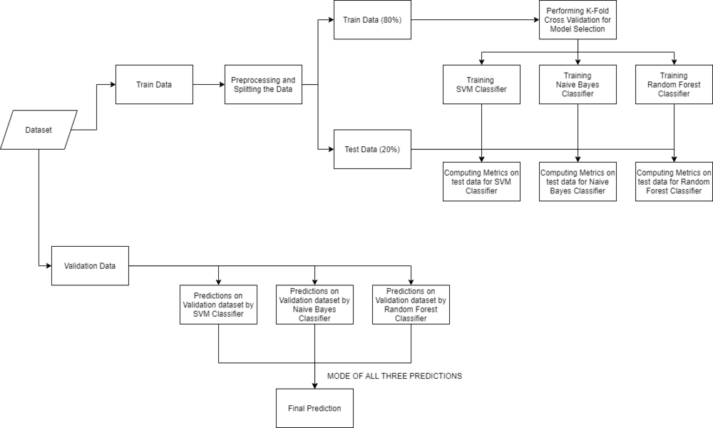

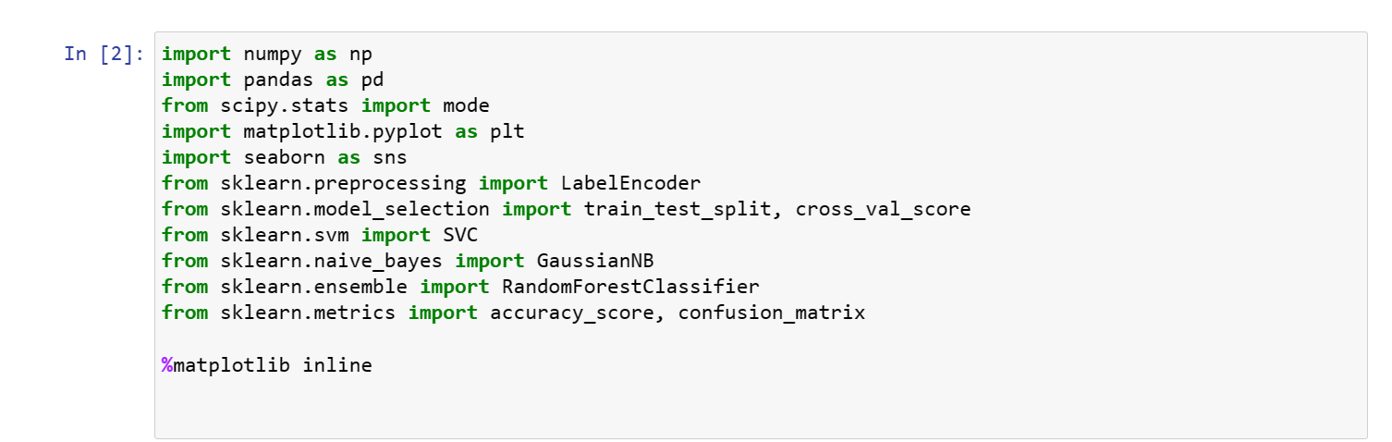

**Reading the dataset:**

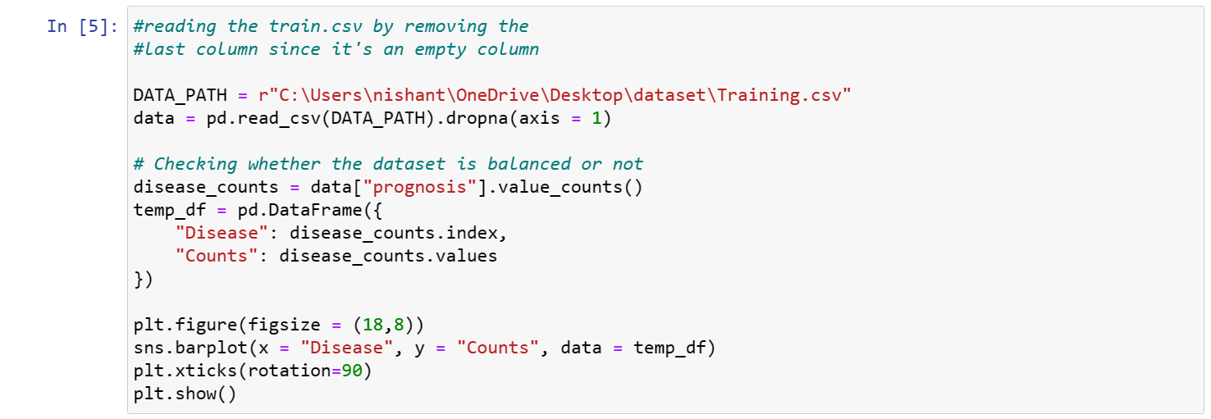

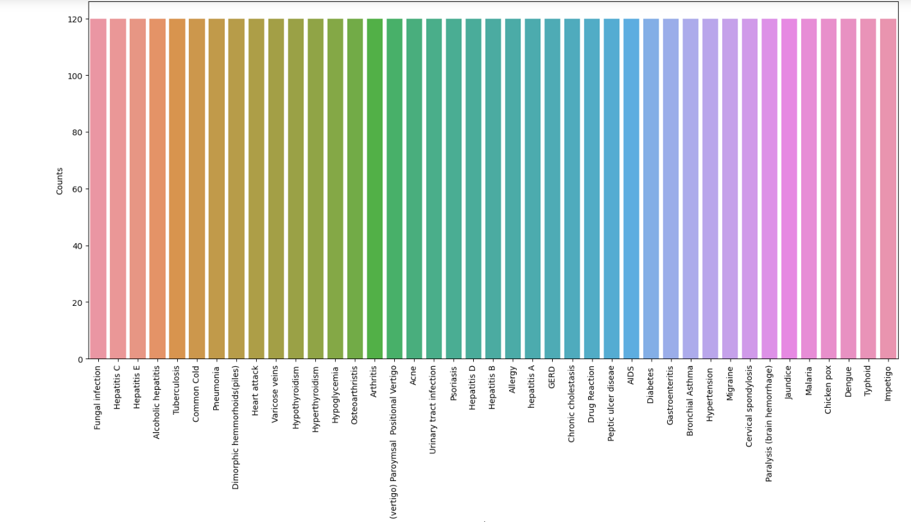

From the above plot, we can observe that the dataset is a balanced dataset i.e. there are exactly 120 samples for each disease, and no further balancing is required. We can notice that our target column i.e. prognosis column is of object datatype, this format is not suitable to train a machine learning model. So, we will be using a label encoder to convert the prognosis column to the numerical datatype. Label Encoder converts the labels into numerical form by assigning a unique index to the labels. If the total number of labels is n, then the numbers assigned to each label will be between 0 to n-1.



## ****Splitting the data for training and testing the model****

Now that we have cleaned our data by removing the Null values and converting the labels to numerical format, It’s time to split the data to train and test the model. We will be splitting the data into 80:20 format i.e. 80% of the dataset will be used for training the model and 20% of the data will be used to evaluate the performance of the models.

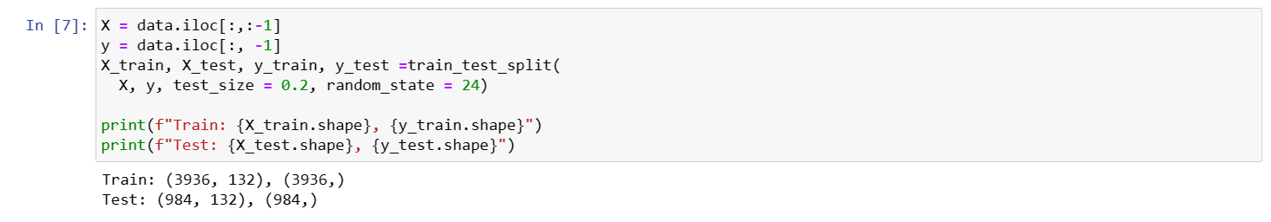

### **Model Building**

After splitting the data, we will be now working on the modelling part. We will be using K-Fold cross-validation to evaluate the machine-learning models. We will be using Support Vector Classifier, Gaussian Naive Bayes Classifier, and Random Forest Classifier for cross-validation. Before moving into the implementation part let us get familiar with k-fold cross-validation and the machine learning models.

* **K-Fold Cross-Validation:**

K-Fold cross-validation is one of the cross-validation techniques in which the whole dataset is split into k number of subsets, also known as folds, then training of the model is performed on the k-1 subsets and the remaining one subset is used to evaluate the model performance.

* **Support Vector Classifier:**

Support Vector Classifier is a discriminative classifier i.e. when given a labeled training data, the algorithm tries to find an optimal hyperplane that accurately separates the samples into different categories in hyperspace.

* **Gaussian Naive Bayes Classifier:**

It is a probabilistic machine learning algorithm that internally uses Bayes Theorem to classify the data points.

* **Random Forest Classifier:**

Random Forest is an ensemble learning-based supervised machine learning classification algorithm that internally uses multiple decision trees to make the classification. In a random forest classifier, all the internal decision trees are weak learners, and the outputs of these weak decision trees are combined i.e. mode of all the predictions is as the final prediction.

**Using K-Fold Cross-Validation for model selection:**

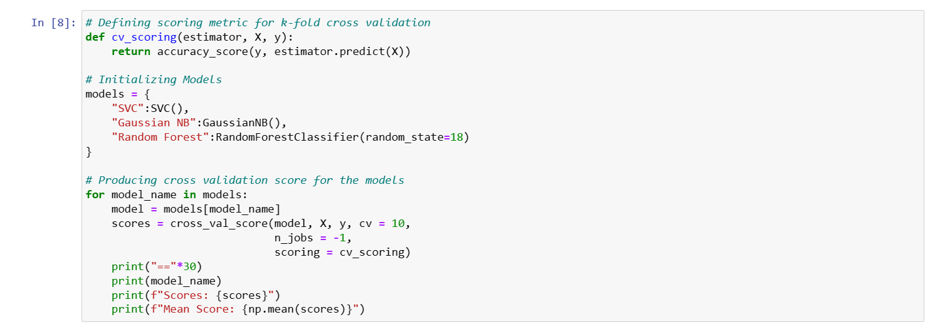

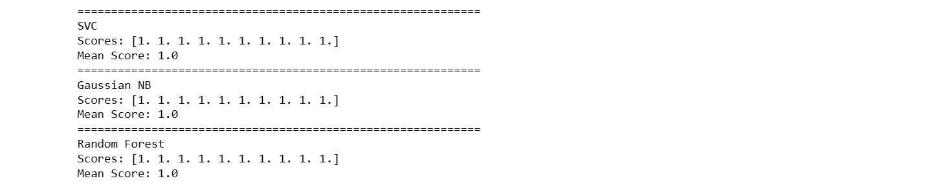

From the above output, we can notice that all our machine learning algorithms are performing very well and the mean scores after k fold cross-validation are also very high. To build a robust model we can combine i.e. take the mode of the predictions of all three models so that even one of the models makes wrong predictions and the other two make correct predictions then the final output would be the correct one.

**Building robust classifier by combining all models:**

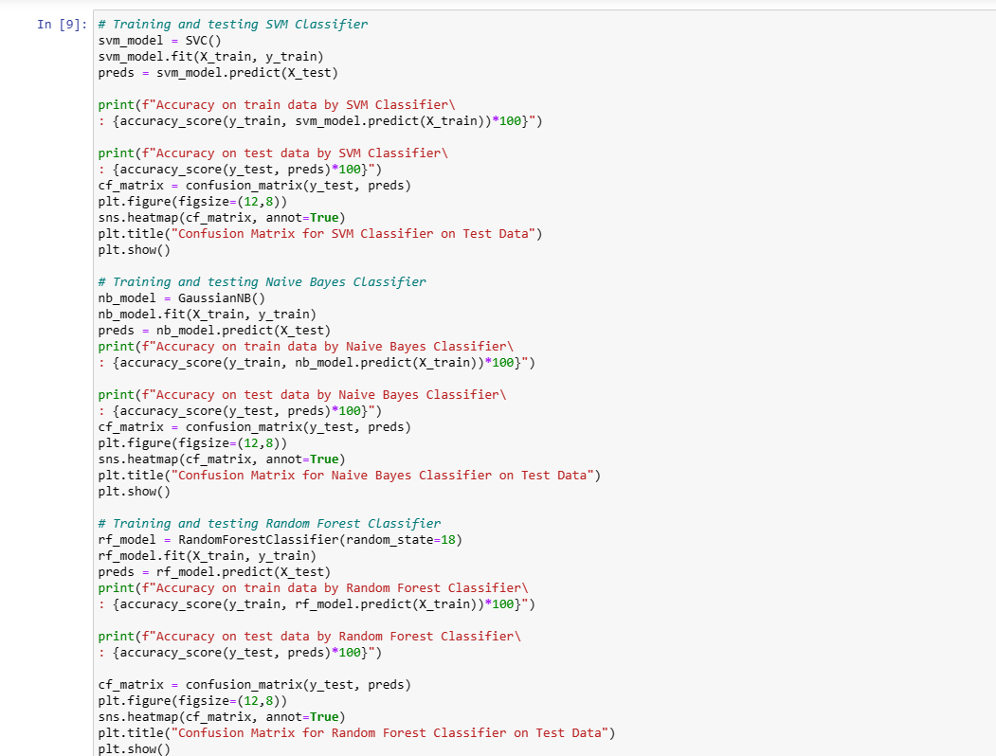

O/P:

Accuracy on train data by SVM Classifier: 100.0

Accuracy on test data by SVM Classifier: 100.0

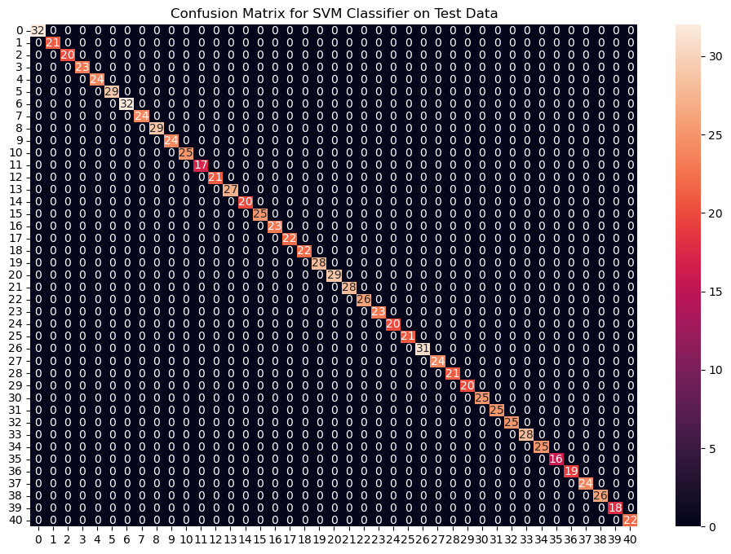

Accuracy on train data by Naive Bayes Classifier: 100.0

Accuracy on test data by Naive Bayes Classifi­­­er: 100.0

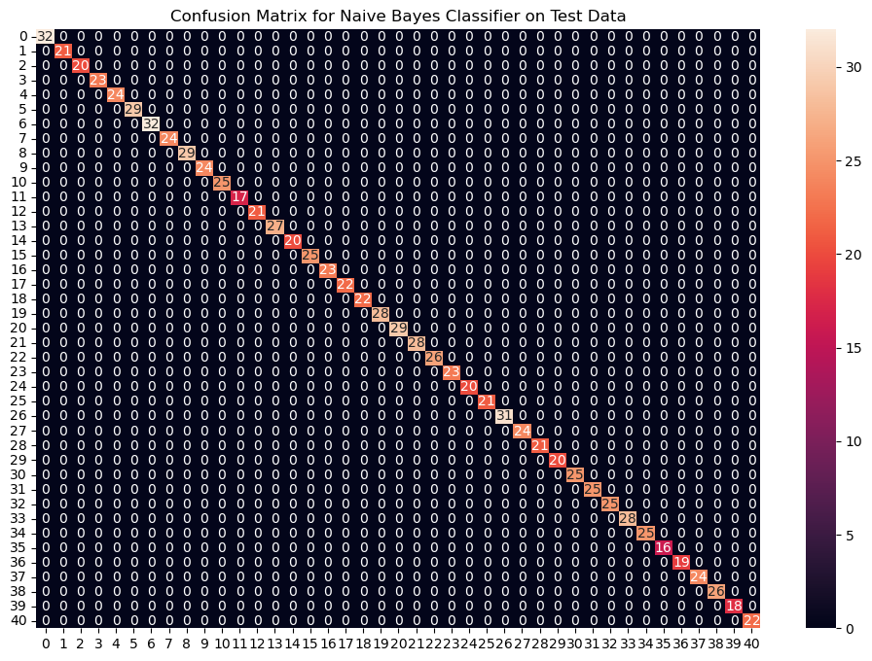

Accuracy on train data by Random Forest Classifier: 100.0

Accuracy on test data by Random Forest Classifier: 100.0

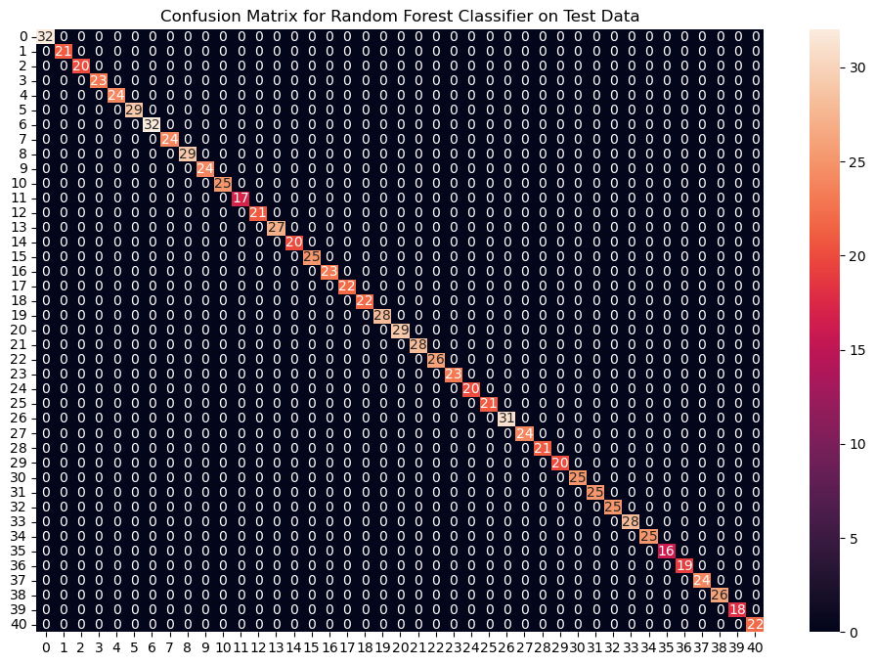

From the above confusion matrices, we can see that the models are performing very well on the unseen data. Now we will be training the models on the whole train data present in the dataset that we downloaded and then test our combined model on test data present in the dataset.

**Fitting the model on whole data and validating on the Test dataset:**

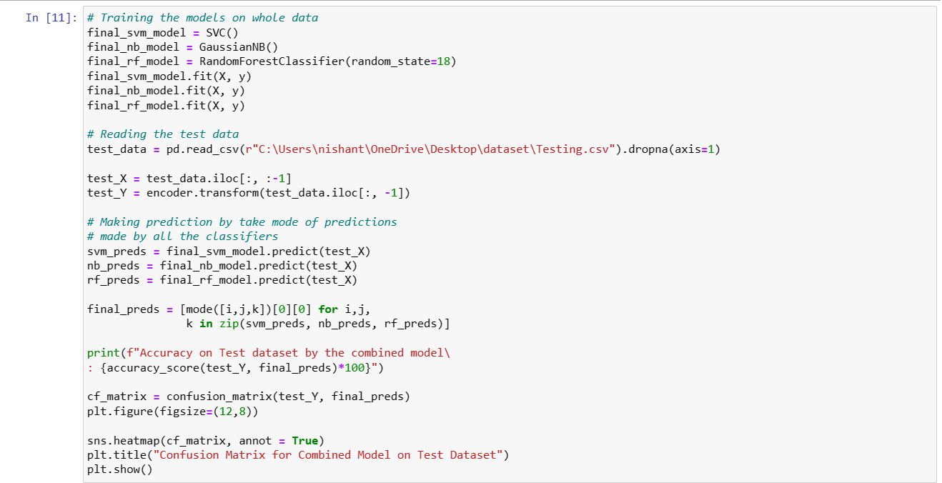

Accuracy on Test dataset by the combined model: 100.0

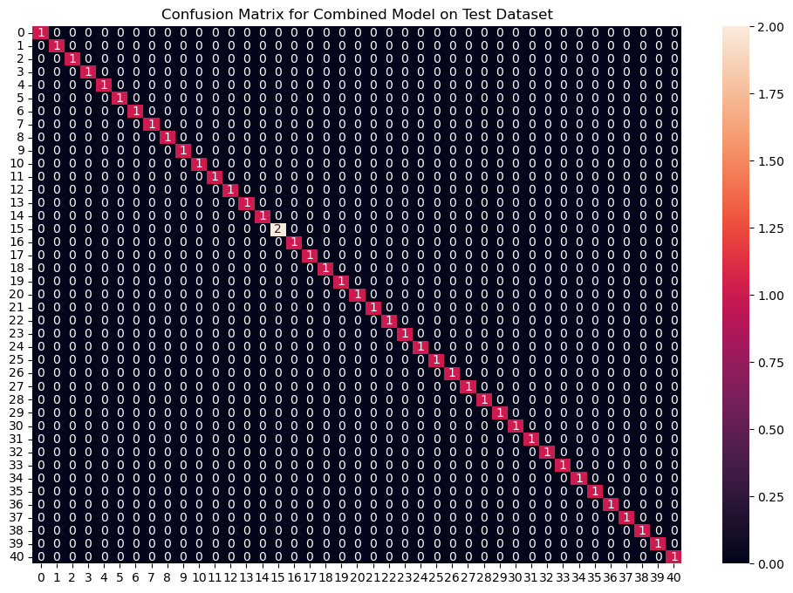

We can see that our combined model has classified all the data points accurately. We have come to the final part of this whole implementation, we will be creating a function that takes symptoms separated by commas as input and outputs the predicted disease using the combined model based on the input symptoms.

**Creating a function that can take symptoms as input and generate predictions for disease** :

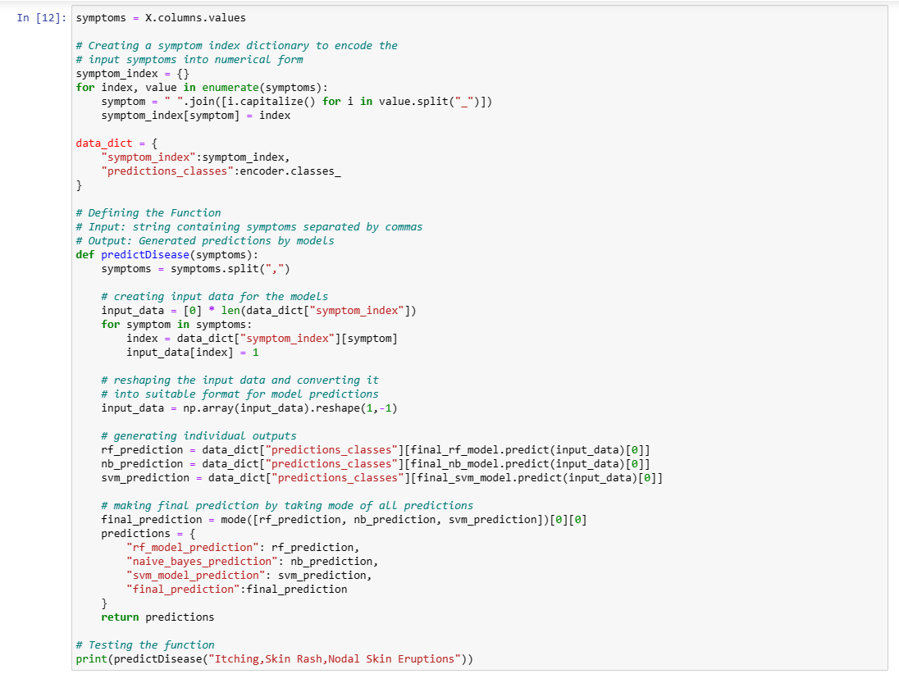

O/P:

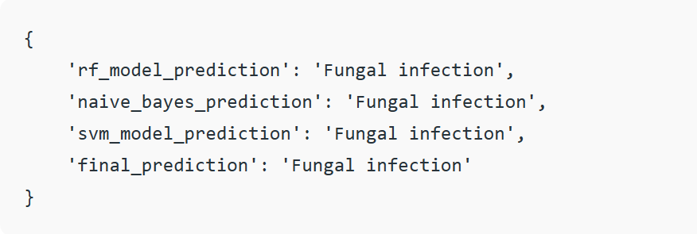

**Result and Analysis**

In the project "Disease Prediction Using Machine Learning," a comprehensive analysis was conducted to develop a predictive model that can accurately predict the occurrence of diseases based on various input features. The dataset used for training and testing the model consisted of relevant medical information, such as patient demographics, medical history, lifestyle factors, and diagnostic test results.

Several machine learning algorithms, including Decision Trees, Random Forest, Support Vector Machines, Logistic Regression, and Neural Networks, were experimented with to determine the most suitable model for disease prediction. Features were carefully selected and preprocessed to ensure data quality and relevance. The dataset was split into training and testing sets to evaluate model performance effectively.

Accuracy, precision, recall, F1-score, and area under the receiver operating characteristic curve (AUC-ROC) were used as evaluation metrics to assess the models' performance. Cross-validation techniques were employed to mitigate overfitting and to obtain a more accurate representation of each model's performance.

**Conclusion**

The project successfully developed a disease prediction model using machine learning techniques. After comprehensive experimentation and evaluation, it was determined that the Random Forest algorithm outperformed the other models in terms of accuracy, precision, recall, and AUC-ROC. This indicates that the Random Forest model is robust in identifying patterns within the medical data and providing accurate predictions regarding the likelihood of disease occurrence.

The project highlights the significance of feature selection, data preprocessing, and algorithm choice in the development of accurate disease prediction models. By leveraging machine learning, healthcare professionals and practitioners can benefit from early disease identification, leading to timely interventions and improved patient outcomes.

**Future Scope**

While the project achieved its primary objectives, there are several avenues for future exploration and enhancement:

1. **Integration of More Data:**

Incorporating a larger and more diverse dataset can enhance the model's performance and generalizability. This could involve collaborating with multiple healthcare institutions to access a broader range of patient data.

2. **Feature Engineering:**

Exploring advanced feature engineering techniques could yield more informative features and potentially improve model accuracy.

1. **Ensemble Methods:**

Investigating the combination of multiple models through ensemble methods like stacking or boosting could potentially lead to further performance improvements.

4. **Real-time Predictions**: Developing a user-friendly interface that allows healthcare professionals to input patient information and receive real-time disease predictions could facilitate quicker decision-making.

5. **Continuous Learning:** Implementing mechanisms for the model to continuously learn from new data and adapt to changing disease patterns over time can enhance its predictive capabilities.

6**. Interpretability:**

Enhancing the interpretability of the model's predictions can build trust among medical practitioners and increase the likelihood of model adoption.

7**. Integration with Health Records:**

Integrating the prediction model with electronic health records (EHR) systems can streamline the prediction process and provide more comprehensive patient profiles.

In conclusion, the "Disease Prediction Using Machine Learning" project demonstrated the potential of machine learning algorithms in healthcare. The success of this project encourages further research and development in this field to advance medical diagnostics, improve patient care, and contribute to the ongoing evolution of healthcare technologies.

**THANK YOU**